PURPOSE
To define procedures to followed in Telephone tracking of Lost to Follow Up (LTFU) from HIV care patients sampled in the BetterInfo Study. Of note, telephone tracking involves two objectives: first is to find out about the outcome of the patient and second is to find out about additional contact information. Conceptually the active tracking process is divided into “phone only” and “field tracking” – the latter which involves phone calls if needed. We divide tracking into these two segments because we are interested in the outcomes which are obtainable through phone tracking alone.

SCOPE
Applies to all Research Staff involved in implementing the BetterInfo study Procedures.

RESPONSIBILITIES
- All staff delegated to track BetterInfo sampled LTFU patients in are responsible for following procedures.
- The Study Coordinator (SC) is responsible to ensure that staff are trained and requirements of this SOP are complied with.

PROCEDURES
- Locate a quiet place where the phone call can be made. Prior to the phone call, ensure you have the following and are familiar with the patient file i.e. date of last visit
- Patient file
- BetterInfo Call Register FO1-01
- Tracker Notebook
- The goal is to try to speak to the patient. If the patient’s contact number cannot be reached, then the buddy or the next of kin’s number should be reached to enquire about the whereabouts of the patients, status and any updated contact details (Phone number and physical address).
- Outcomes found through phone tracking should be documented in the research questionnaire LTFU –Q module B.
- There will be unexpected and unanticipated variability in phone conversations, and the tracker should pursue a natural and polite conversation as a rule.
- We therefore do not have a “script” for this phone conversation.
- Outcomes should be told to the In-Charge and, if available, Peer Educator, so they can complete a patient status form.
- In cases where somebody else answers the patient’s phone, trackers should endeavor not to divulge patient’s information. It should be requested to speak to the patient or if the patient is not available, request for updated contact information. This includes their physical address, with clear directions, and phone number.
- If the patient is successfully reached, introduce yourself and give reasons for calling.
- Enquire from the patient why they have not been able to make it for their appointment. This also should be documented.
- If a patient is contacted, the tracker should solicit whether the patient is in-care elsewhere and the reasons for either stopping or switching care.
- The tracker should have the last visit date as per clinical records available and when asking the patient, should refer to that date (or refer to an interval of time implied by that date).
- Solicitation of a meeting should follow a question about reasons.
- If the quality of the phone conversation (in terms of the connection as well as the rapport) allows, a conversation about reasons can be pursued.
  - Gentle probes can be used but should be limited
  - Repeating what the patient says
  - Asking if the patient can say more about a reason stated
  - Asking if there are other reasons
- Given the limitations of phone conversations, even if reasons are solicited, the tracker should revisit these reasons when the patient is encountered in-person during field tracking.
- Arrange for an appointment to physically visit the patient for follow-up study activities and confirm location for meeting with clear directions.
- The summary of phone tracking workflow is shown in the figure below:

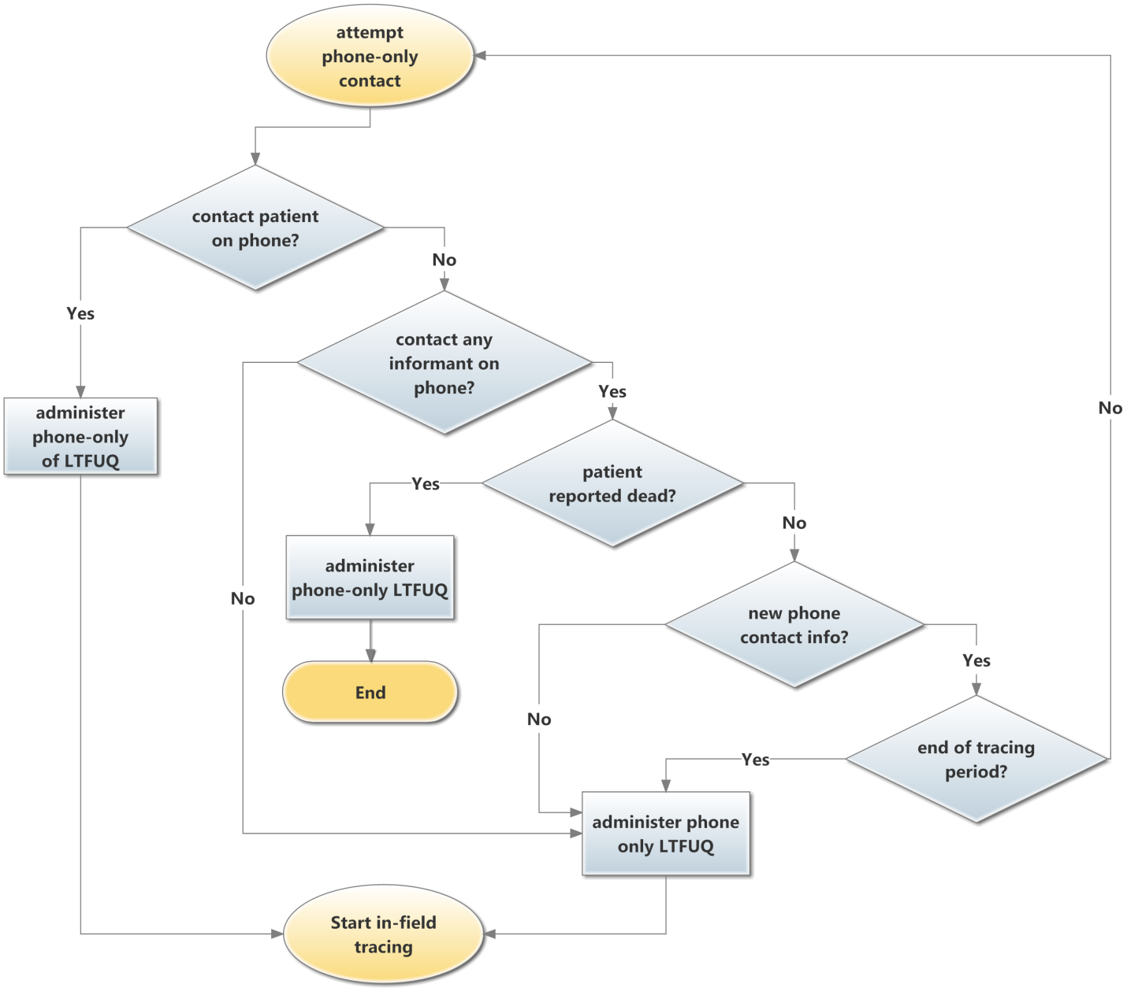

- When a patient is contacted by phone, the tracker should:
- End phone tracking
- Complete phone-only section of the LTFU-Q.
- Field tracking should commence.
- For instances where an informant is contacted, the informant does not have knowledge of patient death, and some updated phone information exists
- The cycle begins again, and phone contact to reach the patient commences
- If a patient is not contacted, and no other informants can be contacted after exhaustive use of available phone contact information, the tracker should:
- End phone-only
- Fill out the phone-only section of the LTFU-Q
- Commence in-field tracking
- NB: exhaustive review of clinical records includes multiple examinations of files or charts and other records, including registers and electronic records if appropriate.
- If an informant is contacted and reports patient has died
- Document outcome in LTFU-Q
- Tracking is over, and case is closed.
- For instances where the informant(s) are contacted, the informant has no information about patients' death but also has no updated contact info via telephone, then:
- Phone tracking is over
- Fill phone tracking section of the LTFU-Q
- Commence field tracking
- NB: if the informant has updated contact information but that information is NOT via the phone, the algorithm stands and the patient should be tracked in person.
- At any point in the tracking process, if the tracking period ends, tracking is over and the appropriate section of the LTFU-Q should be completed.

APPENDICES:

REFERENCES:

Better Info Protocol Version 1.1 and SOP Patient Tracking Guidelines: The Community and Data Team, CIDRZ, CDC, Ministry of Health and PEPFAR.

ABBREVIATIONS AND ACRONYMS
CIDRZ Centre for Infectious Disease Research in Zambia
LTFU Lost to Follow Up

REVISION HISTORY

SOP # | Effective Date | Supersedes | Review Date | Change/Comments

